|  |  |  |
| --- | --- | --- |
| **S. No** | **Title** | **Page No.** |
| **1.** | **Introduction**   |  |  | | --- | --- | | **1.1** | Importance | | **1.2** | Overview | | **1.3** | Objectives and goals | | **1.4** | Key components | | **2-4**   |  | | --- | | 4-6 | | 6-8 | | 8-10 | | 10-14 | |
| **2.** | **Background**   |  |  | | --- | --- | | **2.1** | Definition | | **2.2** | Why is it important | | **2.3** | Advantage of Implementation | | 2.4 | Project Specification | | 2.5 | Mechanism | | **14**   |  | | --- | | 14-16 | | 16-19 | | 19-22 | | 22-25 | | 25-28 | |
| **3.** | **Training and Undertaken**   |  |  | | --- | --- | | **3.1** | Case Diagram | | **3.2** | Methodology | | **3.3** | Hardware, language and software requirements | | **3.4** | Technology used | | **28**   |  | | --- | | 28-30 | | 31-33 | | 33-35 | | 35-38 | |
| **4.** | **Code Snippets**   |  |  | | --- | --- | | **4.1** | Codes | | **4.2** | Source Code File Structure | | **38**   |  | | --- | | 38-44 | | 44-45 | |
| **5.** | **Result and Testing**   |  |  | | --- | --- | | **5.1** | Conclusion | | **5.2** | Significance and impact | | **5.3** | Future scope | | **45**   |  | | --- | | 46-48 | | 48-50 | | 50-52 | |
| **6.** | **References** | 52 |

**Table of contents**

1. **Introduction**

Integrity checks are critical validation procedures used in data management and database systems to ensure the accuracy and consistency of data. They are especially useful in maintaining the reliability of data in a database by flagging and eliminating any instances of data corruption, which can result from hardware or software failures, hacking attempts or even operational errors. Organizations spanning across various industries, from financial services and healthcare to IT and telecommunications, employ integrity checks as part of their data management strategies. These checks come in handy in large–scale data storage systems, data warehousing, data mining, and any domain where data integrity is paramount.

In practice, integrity checks involve running algorithms or specific software tools designed to scan and verify data sequences. They check for any data anomalies such as redundancy, inconsistency, or corruption that may compromise a database’s integrity. If a data error is detected, the system can either automatically correct it or notify database administrators for manual intervention. The primary purpose of integrity checks is to maintain the high quality of data and ensure its reliability over time.

By preserving data integrity, organizations can make informed business decisions, comply with regulatory standards, and safeguard their systems against data breaches or corruption. This data management approach ultimately leads to improved operational efficiency and business performance, building trust among stakeholders and clients in the long run.

**Examlple**

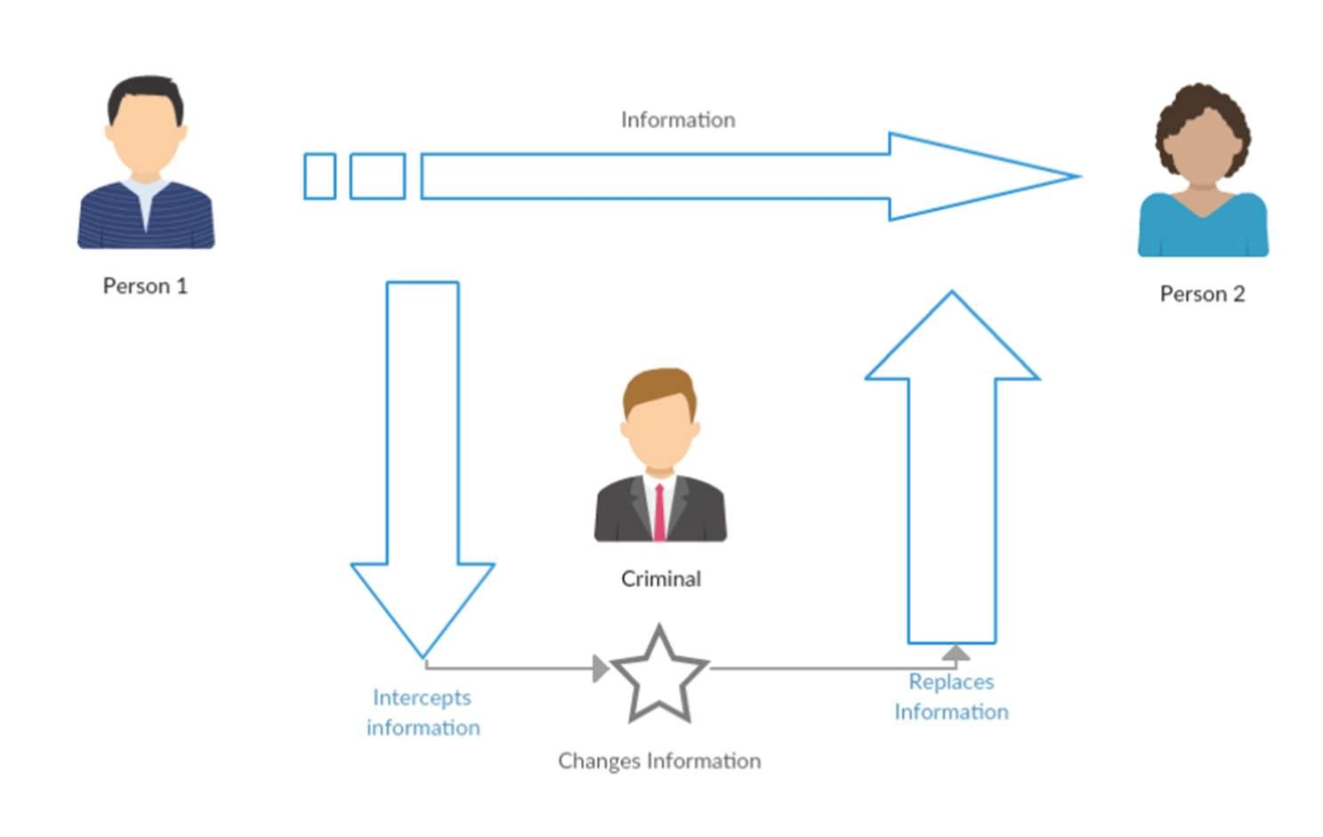

Imagine your computer's operating system as a complex machine with countless interconnected parts. Each part, represented by a system file, plays a crucial role in ensuring smooth operation. However, just like any machine, these files are vulnerable to tampering, which can lead to security breaches, system instability, and unexpected behavior.

This is where the Integrity Checker steps in as your digital guardian. It acts as a vigilant tool that actively protects the integrity and security of your system's core files.

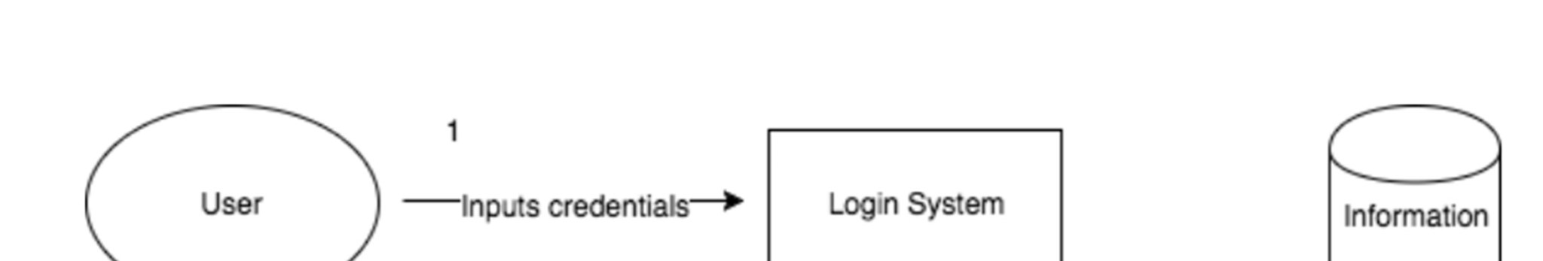

* 1. **Importance**
* **Enhanced Security**: By constantly verifying the authenticity of system files, the Integrity Checker acts as a shield against unauthorized modifications. This helps prevent various security threats like malware attacks, privilege escalation attempts, and system instability caused by corrupted files.
* **Improved System Stability:** Corrupted system files can lead to crashes, freezes, and unexpected behavior. The checker helps ensure system files remain unaltered, promoting system stability and reliability.
* **Faster Incident Response:** The checker provides real-time alerts when discrepancies are found. This enables administrators to quickly identify and address potential security issues, minimizing damage and downtime.
* **Improved Forensics:** The integrity checker maintains a log of file modifications. This information can be invaluable in forensic investigations following a security breach, helping identify compromised files and understand the attacker's actions.

Integrity checks serve as a vital tool in preserving the precision and uniformity of details stored within a database. They function as powerful error-detectors, uncovering any inaccuracies or inconsistencies within data entries. By undertaking such a proactive approach, organizations can ensure that the entirety of their data stored within the database maintains high levels of accuracy and reliability. This helps to avoid potential expensive blunders which could result from inaccurate data. Furthermore, integrity checks empower organizations to make decisions that are grounded in accurate data, thus enhancing overall business performance.

Additionally, integrity checks provide a critical line of defense against harmful activities, such as cyberattacks and security breaches which target crucial data. By enforcing stringent checks on the data’s correctness and enforcing strict access controls, they help the organization to uphold its data security standards and data privacy procedures. As a result, security is improved as only authorized personnel can access the sensitive data, making it less susceptible to unauthorized access or tampering.

The importance of integrity checks becomes even more evident in sectors such as healthcare, finance, and e-commerce, where the handling of sensitive and confidential data is routine. In these industries, any compromise or negligence concerning data integrity could lead to serious consequences, including legal implications and loss of customer trust. Therefore, integrity checks can play a pivotal role in preserving customer trust and satisfaction by ensuring that their sensitive data is always stored accurately and securely.

In total, integrity checks offer a comprehensive solution to maintaining data accuracy while concurrently building security protocols around data access. They are essential not merely for avoiding costly errors but also for safeguarding businesses from damaging cyber threats, maintaining customer faith, and steering business decisions in the right direction.

* 1. **Project Overview**

In an era marked by relentless cyber threats and ever-evolving digital vulnerabilities, the imperative to safeguard the integrity of operating system core files has become a cornerstone of modern cybersecurity practices. The Integrity Checker project stands as a beacon of innovation in this landscape, aiming to fortify system security through a multifaceted approach that transcends traditional paradigms. By combining cutting-edge technology with proactive monitoring and response mechanisms, the Integrity Checker project seeks to establish a new standard of resilience against unauthorized modifications and potential security breaches.

The Integrity Checker project was born out of the imperative to confront the escalating challenges posed by cyber threats to system integrity. With adversaries constantly devising new tactics to infiltrate and compromise digital infrastructures, traditional security measures have proven inadequate in defending against sophisticated attacks targeting critical system files. Recognizing this urgent need for a more robust and proactive defense mechanism, the Integrity Checker project sets out to redefine the boundaries of system security through innovation and ingenuity.

**Key Features and Functionality:**

* **Unveiling Tampering Attempts: The Power of Hashing**

At the heart of the Integrity Checker's arsenal lies a sophisticated hashing technique, which serves as the linchpin of its operation. This technique assigns unique digital fingerprints, known as hashes, to each critical system file, effectively encapsulating their intrinsic integrity. By leveraging advanced hashing algorithms, the Integrity Checker creates a robust mechanism for detecting any deviations or tampering attempts within file content. The immutable nature of hashes ensures that even the slightest alteration to a file triggers a perceptible shift in its hash value, thereby alerting administrators to potential security breaches with unwavering accuracy and precision.

* **Trusted Source: The Role of the Database**

To augment its capabilities and enhance its efficacy, the Integrity Checker relies upon a comprehensive database housing authenticated hash values for every system file. This repository serves as a bastion of trust, embodying the collective knowledge and validation of legitimate file integrity. During the verification process, the Integrity Checker meticulously cross-references the calculated hashes of scanned files against the corresponding values stored within the trusted database. Through this iterative comparison, the Integrity Checker validates the authenticity of each file, offering administrators unparalleled assurance of system integrity and reliability.

* **Real-time Vigilance: Early Detection and Swift Response**

Diverging from the conventional paradigm of intermittent security scans, the Integrity Checker assumes the role of an ever-vigilant sentry, perpetually standing guard over critical system files. Through a regimen of regular, scheduled scans and continuous monitoring, the Integrity Checker maintains a steadfast watchfulness, poised to detect and deter unauthorized modifications in real-time. Upon identifying a deviation between the calculated hash and the trusted value within the database, the Integrity Checker initiates an immediate response, triggering real-time alerts to notify administrators or users of the impending threat. This proactive approach enables swift intervention and decisive action, empowering stakeholders to mitigate potential security breaches before they escalate into systemic vulnerabilities.

* **Beyond Verification: The Broader Impact on Security and Stability**

While the primary mandate of the Integrity Checker revolves around file integrity verification, its significance transcends the confines of this singular function. By actively detecting and thwarting unauthorized modifications, the Integrity Checker assumes a pivotal role in fortifying system security against a myriad of potential threats. Whether combating insidious malware attacks or thwarting attempts at privilege escalation, the Integrity Checker serves as a stalwart guardian, steadfastly defending the sanctity of the digital domain. Moreover, by proactively identifying and addressing potential issues before they manifest as systemic instabilities, the Integrity Checker fosters a climate of resilience and reliability within the digital ecosystem. Through its unwavering dedication to preserving system integrity and functionality, the Integrity Checker heralds a new era of security consciousness, empowering users to navigate the digital landscape with confidence and peace of mind.

* 1. **Objectives and Goals**

The overarching objective of the Integrity Checker project is to establish a comprehensive and proactive defense mechanism to enhance the security posture of operating systems. At its core, the project aims to ensure the integrity and authenticity of critical system files by employing advanced hashing techniques, real-time monitoring capabilities, and a trusted database infrastructure. By doing so, the project seeks to mitigate the risk of unauthorized modifications and potential security breaches, thereby fostering a more resilient and secure computing environment.

**Goals:**

* **Fortify System Security:** The primary goal of the Integrity Checker project is to fortify system security by preventing unauthorized modifications to critical system files. Through the implementation of robust hashing algorithms and continuous monitoring mechanisms, the project aims to create a formidable barrier against cyber threats seeking to compromise system integrity.
* **Detect and Respond to Threats:** A key goal of the Integrity Checker is to detect and respond to security threats in real-time. By actively monitoring system files and comparing their hash values against authenticated references stored in a trusted database, the project endeavors to swiftly identify deviations and trigger immediate alerts, enabling administrators to take proactive measures to mitigate potential risks.
* **Ensure File Integrity and Authenticity:** The Integrity Checker project is dedicated to ensuring the integrity and authenticity of system files by meticulously verifying their hash values against authenticated records. By maintaining a comprehensive database of known good hash values and performing regular integrity checks, the project aims to provide administrators with confidence in the reliability of their system files.
* **Facilitate Swift Incident Response:** An essential goal of the Integrity Checker project is to facilitate swift incident response in the event of unauthorized modifications or security breaches. By issuing real-time alerts and notifications upon detecting discrepancies in file hash values, the project empowers administrators to promptly investigate and remediate potential threats, thereby minimizing the impact on system security.
* **Promote System Stability:** Beyond ensuring file integrity, the Integrity Checker project seeks to promote overall system stability by proactively identifying and addressing potential issues before they escalate. By serving as an early warning system for file corruption or tampering attempts, the project helps mitigate the risk of system instability, crashes, and disruptions to user productivity.
* **Empower Security Awareness:** Ultimately, the Integrity Checker project aims to empower users and administrators with a heightened awareness of cybersecurity risks and best practices. By providing tools and resources to enhance system security and resilience, the project strives to foster a culture of proactive risk management and vigilance in safeguarding digital assets.
  1. **Key Components**

In the complex realm of cybersecurity, where threats lurk in the shadows of digital landscapes, the Integrity Checker project emerges as a beacon of resilience, fortified by a multitude of intricate components meticulously woven together to safeguard the sanctity of core system files. These components, each imbued with specific functionalities and synergistic capabilities, collectively form the backbone of the Integrity Checker, empowering it to detect, deter, and defend against evolving cyber threats. Let us embark on a comprehensive exploration of the key components that comprise the essence of the Integrity Checker:

**Hash-based Verification Mechanism:**

* **Fingerprint Analysis:** At the core of the Integrity Checker's efficacy lies a sophisticated mechanism that harnesses digital fingerprints, known as hashes or checksums. These cryptographic representations encapsulate the essence of each file, akin to unique digital identities, facilitating granular analysis of file integrity.
* **Comparison with Trusted Database**: Central to its operation, the Integrity Checker meticulously computes the hash value of each scanned system file and juxtaposes it against a meticulously curated repository of known good hash values stored within a trusted database. This rigorous comparison serves as a litmus test, enabling the detection of even the most subtle deviations indicative of potential tampering or unauthorized modifications.

**Real-time Monitoring and Alerting System:**

* **Constant Vigilance**: In the dynamic landscape of cyber threats, the Integrity Checker assumes the mantle of a vigilant sentinel, perpetually scanning critical system files with unwavering diligence. Through a regimen of regular scans and continuous monitoring, it maintains an unyielding vigil, poised to detect any aberrations or anomalies that may compromise system integrity.
* **Immediate Notifications:** Upon uncovering a discrepancy between the calculated hash and the trusted value stored within the database, the Integrity Checker springs into action, issuing real-time alerts with celerity and precision. These alerts serve as a clarion call to action, galvanizing administrators into swift response to mitigate potential security breaches and fortify system defenses.

**Configurability and Customization Options:**

* **Scope Definition:** Recognizing the diverse needs and exigencies of varied environments, the Integrity Checker offers administrators the flexibility to delineate the scope of files subjected to scrutiny. This nuanced control empowers administrators to strike an optimal balance between stringent security measures and operational efficiency, tailoring the Integrity Checker's operations to suit the unique contours of their ecosystem.
* **Scheduling Scans**: In the quest for preemptive security measures, the Integrity Checker facilitates the scheduling of regular scans at predefined intervals. This strategic scheduling ensures the timely detection of unauthorized changes while mitigating potential disruptions to system operations, thereby fostering a harmonious synergy between security imperatives and operational exigencies.

**Logging and Reporting Infrastructure:**

* **Comprehensive Log Maintenance**: As an indispensable repository of historical data and actionable insights, the Integrity Checker diligently maintains a comprehensive log of file modifications. Each log entry, replete with detailed timestamps and discrepancy reports, serves as a veritable breadcrumb trail, enabling forensic analysis and retrospective investigation of security incidents.
* **Advanced Reporting Capabilities**: Leveraging the wealth of data at its disposal, some iterations of the Integrity Checker boast advanced reporting features that transcend mere documentation, offering nuanced insights into system file integrity trends over time. These reports, characterized by their analytical depth and prescriptive value, empower administrators to glean actionable intelligence, inform strategic decision-making, and proactively manage security risks.

**Integration Potential with Security Ecosystem**:

* **Synergistic Collaboration**: Recognizing the transformative potential of collaborative synergies, the Integrity Checker project is architected to seamlessly integrate with broader security ecosystems. Through interoperability with complementary security solutions and standardized interfaces, it fosters centralized management, orchestration, and correlation of security events, culminating in a holistic and cohesive approach to system security.

**Additional Considerations**:

* **Trusted Database Maintenance**: The efficacy of the Integrity Checker hinges on the integrity and currency of its trusted database, necessitating meticulous upkeep and regular updates. Administrators must exercise due diligence in curating this repository of authenticated hash values, ensuring its fidelity and reliability as the cornerstone of file integrity verification.
* **Optimization of System Resource Usage:** While the Integrity Checker serves as a stalwart guardian of system integrity, its operational footprint may exert a discernible impact on system resources. Administrators are tasked with the delicate balancing act of optimizing scan frequency, scope, and resource utilization to harmonize security imperatives with performance considerations, thus maximizing operational efficiency without compromising on security efficacy.

In essence, the Integrity Checker project epitomizes a symphony of technological innovation, operational excellence, and unwavering commitment to system security. These key components, meticulously crafted and meticulously orchestrated, converge to form an indomitable bulwark against the ever-evolving specter of cyber threats, empowering stakeholders to navigate the digital terrain with confidence, resilience, and peace of mind

1. **Background**
   1. **Definition:**

An integrity checker is a vital component of cybersecurity infrastructure, serving as a vigilant guardian of data integrity and system security. This sophisticated tool operates within a broader ecosystem of cybersecurity measures, diligently monitoring, and validating the authenticity, accuracy, and consistency of data and system components. The code provided presents a user-friendly interface that encapsulates the essence of integrity checks, empowering users to create baselines, perform integrity checks, and generate reports seamlessly.

At its core, an integrity checker functions as a sentinel, safeguarding against unauthorized modifications, tampering, or corruption that threaten the integrity and reliability of data and systems. It embodies the principles of cybersecurity by leveraging cryptographic techniques to assess the trustworthiness of files, directories, or entire systems. Through meticulous hashing algorithms and baseline establishment mechanisms, it establishes a foundation of trust, enabling users to detect deviations from the established norms.

The importance of integrity checks transcends mere data validation; it forms the cornerstone of cybersecurity resilience and operational stability. By ensuring data accuracy and reliability, integrity checks fortify the foundations upon which critical business decisions are made. They instill confidence among stakeholders, customers, and partners, fostering a culture of trust and accountability within organizations.

The mechanisms embedded within the code exemplify the sophistication and versatility of integrity checks. Cryptographic hashing, an indispensable technique, generates unique fingerprints for files or data sets, enabling comparisons against baseline values for anomaly detection. The establishment of baselines provides a reference point for subsequent integrity assessments, facilitating proactive detection of deviations. Moreover, the code incorporates real-time alerting and response capabilities, empowering administrators to swiftly mitigate integrity violations and mitigate potential risks.

The significance of integrity checks extends beyond cybersecurity realms, permeating various industries and regulatory landscapes. In sectors such as finance, healthcare, and e-commerce, where data integrity is paramount, integrity checks serve as a bulwark against potential threats and vulnerabilities. Compliance with regulatory standards and industry best practices is facilitated through the rigorous implementation of integrity checks, ensuring adherence to data protection and privacy regulations.

Furthermore, integrity checks play a pivotal role in incident response and forensic investigations. By maintaining detailed logs of file modifications and integrity assessments, organizations can reconstruct events following security breaches or data incidents. This forensic intelligence enables security teams to identify compromised files, understand attacker tactics, and bolster defensive strategies.

In essence, the integrity checker encapsulates the ethos of cybersecurity resilience, embodying principles of trust, reliability, and accountability. Its role as a digital guardian extends beyond mere validation; it empowers organizations to navigate the complexities of modern cybersecurity landscapes with confidence and resilience. Through continuous monitoring, validation, and response mechanisms, integrity checks uphold the integrity and security of data and systems, safeguarding against evolving threats and vulnerabilities. As organizations strive to maintain competitive advantage and trust in an increasingly digital world, the integrity checker remains an indispensable ally, ensuring the integrity and trustworthiness of data assets and systems.

**2.2. Why is it important?**

The importance of integrity checkers in today's digital landscape cannot be overstated. As organizations increasingly rely on digital data and systems to conduct their operations, ensuring the integrity of this data becomes paramount. An integrity checker serves as a crucial safeguard against data corruption, unauthorized alterations, and malicious tampering, providing organizations with confidence in the accuracy, reliability, and trustworthiness of their data assets. In this article, we will explore the multifaceted importance of integrity checkers in detail.

* **Data Integrity and Reliability**:

At the core of any organization's operations lies its data. Whether it's customer information, financial records, or proprietary data, the integrity of this information is paramount. An integrity checker verifies the authenticity and consistency of data, ensuring that it has not been altered or corrupted in any unauthorized manner. By detecting discrepancies or anomalies in data sets, integrity checkers help maintain data integrity and reliability, which are essential for making informed decisions, complying with regulatory requirements, and maintaining stakeholder trust.

* **Protection Against Data Corruption:**

Data corruption can occur due to various factors, including hardware failures, software bugs, human errors, and malicious attacks. Even minor corruption in critical data can have significant consequences, leading to financial losses, operational disruptions, and reputational damage. Integrity checkers act as a frontline defense against data corruption by detecting and mitigating integrity violations promptly. By identifying corrupted data early on, organizations can take corrective actions to prevent further damage and restore data integrity before it escalates into a more significant issue.

* **Security Assurance:**

In an era where cyber threats are ever-present and evolving, ensuring the security of data is a top priority for organizations. Integrity checkers play a crucial role in bolstering data security by detecting unauthorized modifications or tampering attempts. By employing cryptographic hashing algorithms, integrity checkers generate unique fingerprints (hash values) for data sets, which can be compared against baseline values to detect any alterations. This helps organizations detect and mitigate security breaches, insider threats, and other malicious activities that could compromise data integrity and confidentiality.

* **Compliance and Regulatory Requirements:**

Many industries are subject to stringent regulatory requirements and compliance standards governing data protection, privacy, and security. Integrity checkers help organizations meet these requirements by providing mechanisms to validate data integrity and demonstrate adherence to regulatory mandates. By implementing integrity checks as part of their compliance programs, organizations can ensure that their data management practices align with industry regulations and standards, thereby avoiding penalties, legal consequences, and reputational damage.

* **Operational Stability and Continuity:**

Data integrity is closely tied to operational stability and continuity. Any disruption or compromise in data integrity can lead to system failures, downtime, and operational disruptions, affecting business continuity and productivity. Integrity checkers help maintain operational stability by proactively detecting and mitigating integrity violations, ensuring that systems and data remain available, reliable, and consistent. By safeguarding against data corruption and unauthorized alterations, integrity checkers contribute to maintaining uninterrupted operations and mitigating the risks of downtime and disruptions.

* **Trust and Reputation:**

Trust is a cornerstone of any successful organization. Maintaining the integrity of data is essential for building and preserving trust among stakeholders, customers, and partners. Integrity checkers demonstrate a commitment to data integrity, security, and accountability, fostering trust and confidence in an organization's data management practices. By providing assurances that data is accurate, reliable, and secure, integrity checkers help organizations uphold their reputation and credibility in the eyes of stakeholders, thereby enhancing brand value and competitiveness.

* **Forensic Capabilities:**

In the event of a security breach or data incident, integrity checkers play a crucial role in forensic investigations. By maintaining detailed logs of integrity checks, including timestamps, actions performed, and results obtained, integrity checkers provide valuable forensic evidence that can be used to reconstruct events, identify the source of a breach, and mitigate future risks. This forensic intelligence enables organizations to respond effectively to security incidents, minimize damage, and enhance their cybersecurity posture.

In conclusion, integrity checkers are indispensable tools for ensuring the integrity, security, and reliability of data in today's digital age. By proactively detecting and mitigating integrity violations, integrity checkers help organizations safeguard their data assets, maintain operational stability, comply with regulatory requirements, build trust with stakeholders, and respond effectively to security incidents. As organizations continue to navigate the complexities of the digital landscape, integrity checkers will remain essential components of their cybersecurity arsenal, enabling them to protect and preserve the integrity of their most valuable asset: data**.**

**2.3.** **Project Specification**

The project aims to develop an integrity checker tool that ensures the authenticity, accuracy, and reliability of data stored within files and directories. This tool will provide functionalities for creating baselines, performing integrity checks, and generating reports to detect any unauthorized alterations or tampering.

1. **Features and Functionalities:**

* **Baseline Creation:** Users can specify directories for baseline creation, during which hash values for all files within the directories will be calculated and stored as reference points.
* **Integrity Checks**: The integrity checker will compare current hash values of files with baseline hash values to detect any discrepancies or modifications. It will flag files or directories that have been altered since the baseline was created.
* **Report Generation**: The tool will generate comprehensive reports summarizing the results of integrity checks, including details on detected discrepancies, timestamps, and affected files or directories.
* **Automated Alerting**: An alerting mechanism will be implemented to notify users or administrators when integrity violations are detected. This may include email notifications, log entries, or real-time alerts.
* **Baseline Management:** Users will have the ability to manage baseline records, including storage, retrieval, and deletion. Baseline records will be securely stored to ensure their integrity and confidentiality.
* **Logging and Auditing:** The tool will maintain detailed logs of integrity checks, including timestamps, actions performed, and results obtained. These logs will be invaluable for troubleshooting, forensic analysis, and compliance purposes.

1. **Implementation Details:**
   * **Programming Language:** The integrity checker tool will be developed primarily using shell scripting (e.g., Bash) for cross-platform compatibility and ease of implementation.
   * **Cryptographic Hashing:** Cryptographic hashing algorithms (e.g., SHA-256) will be employed to generate unique fingerprints (hash values) for files and directories, enabling comparison with baseline values.
   * **User Interface:** The tool will feature a user-friendly interface, which could be command-line based or include a simple graphical interface for ease of use.
   * **Error Handling:** Robust error handling and recovery mechanisms will be implemented to handle unexpected situations gracefully and ensure the reliability and stability of the tool.
2. **Testing and Validation:**
   * **Unit Testing:** Unit tests will be conducted to validate the functionality of individual components and functions within the integrity checker tool.
   * **Integration Testing:** Integration tests will verify the behavior of the integrity checker as a whole, ensuring seamless interaction between different modules and functionalities.
   * **User Acceptance Testing:** User acceptance tests will involve real users or stakeholders evaluating the usability, effectiveness, and reliability of the integrity checker in a simulated or real-world environment.
3. **Documentation and User Guide:**
   * **User Guide:** A comprehensive user guide will be provided to assist users in installing, configuring, and using the integrity checker tool effectively. It will include instructions, examples, and troubleshooting tips to facilitate adoption and usage.
   * **Technical Documentation:** Detailed technical documentation will be prepared, documenting the design, implementation, and inner workings of the integrity checker tool. It will provide insights into the underlying algorithms, data structures, and implementation details for developers and contributors.
4. **Deployment and Distribution:**
   * **Packaging:** The integrity checker tool will be packaged into a distributable format for easy deployment on various operating systems and environments.
   * **Distribution Channels:** The tool will be made available for download through online repositories, version control platforms (e.g., GitHub), or project websites.
5. **Licensing:**
   * **Open-Source License:** The integrity checker tool will be released under an appropriate open-source license (e.g., MIT License, GNU General Public License) to specify how others can use, modify, and distribute the code.
6. **Project Management:**
   * **Version Control:** Git will be used for version control, enabling collaborative development, tracking of changes, and coordination among team members.

Issue Tracking: Issue tracking systems (e.g., GitHub Issues, Jira) will be used to manage and prioritize tasks, track bugs, and coordinate development efforts.

**2.4. Advantage of Implementation**

Implementing an integrity checker offers numerous advantages for organizations across various industries, ranging from enhanced data security and regulatory compliance to improved operational efficiency and risk mitigation. In this article, we will explore the key advantages of implementing an integrity checker in detail.

* **Enhanced Data Security:**

Implementing an integrity checker strengthens data security by providing a robust mechanism for detecting unauthorized modifications, tampering, or corruption of data. By regularly monitoring and validating the integrity of data assets, organizations can identify and mitigate security breaches, insider threats, and other malicious activities that could compromise data confidentiality and integrity. This proactive approach to data security helps organizations maintain trust and confidence among stakeholders, customers, and partners.

* **Regulatory Compliance:**

Many industries are subject to stringent regulatory requirements and compliance standards governing data protection, privacy, and security. Implementing an integrity checker helps organizations meet these requirements by providing mechanisms to validate data integrity and demonstrate adherence to regulatory mandates. By maintaining accurate and reliable data records, organizations can avoid penalties, legal consequences, and reputational damage associated with non-compliance.

* **Early Detection of Data Corruption:**

Data corruption can occur due to various factors, including hardware failures, software bugs, human errors, and cyberattacks. Implementing an integrity checker enables organizations to detect data corruption early on, allowing them to take corrective actions before it escalates into a more significant issue. By identifying corrupted data promptly, organizations can minimize the impact on operations, prevent data loss, and maintain business continuity.

* **Operational Continuity and Resilience:**

Data integrity is closely linked to operational continuity and resilience. Any disruption or compromise in data integrity can lead to system failures, downtime, and operational disruptions, affecting business continuity and productivity. Implementing an integrity checker helps organizations maintain operational stability by proactively detecting and mitigating integrity violations. By safeguarding against data corruption and unauthorized alterations, integrity checkers contribute to maintaining uninterrupted operations and mitigating the risks of downtime and disruptions.

* **Improved Decision-Making:**

Accurate and reliable data is essential for making informed decisions and strategic planning. Implementing an integrity checker ensures that the data used for analysis, reporting, and decision-making is accurate, complete, and trustworthy. By providing assurances about data integrity, organizations can make better-informed decisions, mitigate risks, and capitalize on opportunities more effectively, leading to improved business outcomes and competitive advantage.

* **Forensic Capabilities:**

In the event of a security breach or data incident, an integrity checker provides valuable forensic capabilities for investigating and analyzing the integrity of data assets. By maintaining detailed logs of integrity checks, including timestamps, actions performed, and results obtained, integrity checkers enable organizations to reconstruct events, identify the source of a breach, and mitigate future risks. This forensic intelligence enhances incident response capabilities, facilitates regulatory compliance, and strengthens overall cybersecurity posture.

* **Cost Savings and Efficiency:**

Implementing an integrity checker can lead to cost savings and efficiency gains by reducing the likelihood of data corruption, security breaches, and regulatory penalties. By proactively monitoring and validating data integrity, organizations can minimize the impact of data-related incidents, avoid costly downtime, and streamline compliance efforts. Additionally, the automation of integrity checking processes helps organizations save time and resources, allowing them to focus on strategic initiatives and core business activities.

**2.5. Mechanism**

The mechanism of integrity checks involves a systematic process of verifying the integrity, authenticity, and consistency of data, files, or systems. Integrity checks utilize various techniques and methodologies to ensure that data remains unaltered, trustworthy, and secure. Here's a detailed overview of the mechanism of integrity checks:

* **Baseline Establishment:**
* The integrity check process begins with the establishment of a baseline, which serves as a reference point for verifying data integrity. The baseline represents the original, unaltered state of the data or system at a specific point in time.
* Baselines can be created by computing hash values or checksums for files, directories, or datasets using cryptographic hash functions. These hash values serve as unique digital fingerprints of the data, enabling comparison with subsequent versions to detect any changes or modifications.
* **Hash Calculation:**
* To verify data integrity, integrity checks compute hash values for files, documents, or datasets using cryptographic hash functions such as SHA-256 or MD5.
* Hash values are generated by processing the input data through the hash function, resulting in a fixed-size string of characters that uniquely represents the data. This hash value serves as a digital signature of the data, facilitating verification and authentication.
* **Comparison with Baseline:**
* Once hash values are computed for the current version of the data, integrity checks compare these hash values with the baseline values established during the baseline creation phase.
* If the computed hash values match the baseline values, it indicates that the data remains unchanged and has retained its integrity since the baseline was established. Any discrepancies or differences between the computed and baseline hash values may signify data tampering, corruption, or unauthorized modifications.
* **Detection of Changes:**
* Integrity checks meticulously analyze any differences or discrepancies between the computed hash values and the baseline values to identify changes or modifications to the data.
* Changes detected during the integrity check process may include alterations to file contents, metadata changes, unauthorized access, or tampering attempts.
* **Alerting and Reporting:**
* Upon detecting changes or discrepancies, integrity checks trigger alerts or notifications to notify administrators or users of potential security breaches or integrity violations.
* Additionally, integrity checks generate comprehensive reports detailing the results of the integrity verification process, including information on detected changes, timestamps, and affected files or systems.
* **Remediation and Response:**
  + In response to detected changes or integrity violations, organizations take appropriate remedial actions to restore data integrity and mitigate security risks.
  + Remediation measures may include restoring data from backups, investigating the root cause of the integrity violation, implementing security patches or updates, and enhancing security controls to prevent future incidents.
* **Continuous Monitoring and Maintenance:**
* Integrity checks are conducted regularly and periodically to ensure ongoing data integrity and security.
* Continuous monitoring and maintenance of integrity checks involve updating baseline values, adjusting monitoring parameters, and refining detection mechanisms to adapt to evolving threats and security requirements.

In summary, the mechanism of integrity checks encompasses the establishment of baselines, computation of hash values, comparison with baseline values, detection of changes, alerting and reporting, remediation and response, and continuous monitoring and maintenance. By employing robust integrity check mechanisms, organizations can ensure the integrity, authenticity, and security of their data and systems, thereby mitigating risks and safeguarding against potential threats and vulnerabilities.

1. **Training and Undertaken**
   1. **Case Diagram**

Creating a use case diagram for testing and undertaking integrity checks involves identifying the actors involved, the actions they perform, and the interactions with the system. Here's a conceptual description of such a use case diagram:

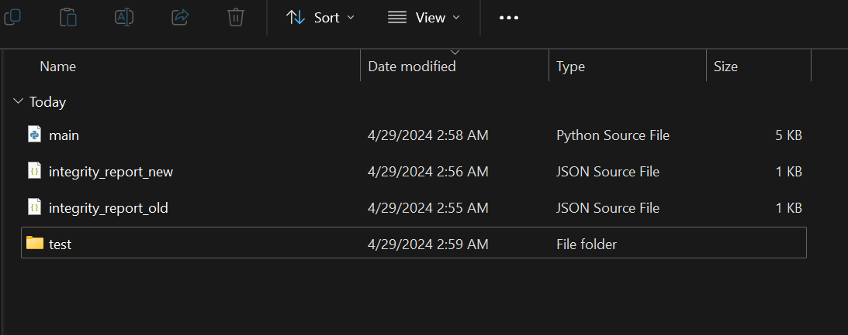

* **Actors:**
* **Administrator:** The primary actor responsible for initiating and overseeing integrity checks. The administrator configures the integrity check parameters, initiates manual checks, and receives notifications or alerts about integrity violations.
* **System:** The system itself, representing the software or platform that conducts integrity checks. It interacts with the administrator to perform integrity checks, compare hash values, and detect changes in data or files.
* **Use Cases:**
* **Configure Integrity Check Parameters:** The administrator configures the parameters for integrity checks, including the frequency of checks, the scope of files or directories to monitor, and the notification settings.
* **Initiate Integrity Check:** The administrator initiates the integrity check process either manually or according to the predefined schedule. The system computes hash values for the specified files or directories and compares them with baseline values.
* **Detect Changes:** The system detects changes in data or files during the integrity check process. This includes identifying discrepancies between computed hash values and baseline values, indicating potential data tampering or integrity violations.
* **Notify Administrator**: If changes or discrepancies are detected, the system notifies the administrator about the integrity violations. Notifications may include alerts, emails, or dashboard notifications, informing the administrator of the detected changes and providing relevant details for further investigation.
* **Investigate Integrity Violations:** Upon receiving notifications, the administrator investigates the integrity violations to determine the cause and severity of the issue. This may involve reviewing log files, analyzing system activity, and identifying potential security threats or vulnerabilities.
* **Resolve Integrity Violations**: Based on the investigation findings, the administrator takes appropriate actions to resolve integrity violations and restore data integrity. This may include restoring data from backups, applying security patches, or implementing corrective measures to prevent future incidents.
* **Relationships:**
* The administrator actor initiates and interacts with all use cases related to configuring, initiating, detecting, notifying, investigating, and resolving integrity violations.
* The system actor performs the actions associated with integrity checks, including computing hash values, comparing them with baseline values, and detecting changes.
* **Generalization:**
* If there are multiple types of administrators with different roles or permissions (e.g., super admin, regular admin), you can generalize them under a common "Administrator" actor.
* Grouping and Organization:
* Group related use cases together to create a more organized diagram. For example, all use cases related to integrity check initiation and detection could be grouped together.

This conceptual use case diagram outlines the interactions between actors and the system during the testing and undertaking of integrity checks. It provides a visual representation of the various functionalities involved in ensuring data integrity and security. You can use diagramming tools to create a visual representation of this use case diagram, incorporating shapes, labels, and relationships to enhance clarity and comprehension.

* 1. **Methodology**

Creating a methodology for integrity checks involves outlining a structured approach to verify the integrity, authenticity, and consistency of data or systems. Here's a comprehensive methodology for conducting integrity checks:

* **Define Objectives and Scope:**
* Clearly define the objectives of the integrity checks, such as ensuring data integrity, detecting unauthorized changes, or verifying system configurations.
* Determine the scope of the integrity checks, including the types of data or files to be monitored, the frequency of checks, and the stakeholders involved.
* **Identify Assets and Baselines:**
* Identify the critical assets or data to be protected, including files, databases, configurations, or system components.
* Establish baselines by computing hash values or checksums for the identified assets, creating a reference point for comparison during integrity checks.
* **Select Integrity Check Tools and Techniques:**
* Choose suitable tools and techniques for conducting integrity checks based on the objectives and scope defined earlier.
* Utilize automated integrity check tools, such as file integrity monitoring (FIM) systems, intrusion detection systems (IDS), or custom scripts, to streamline the verification process.
* **Configure Parameters and Policies:**
* Configure integrity check parameters, including the frequency of checks, the scope of monitored assets, notification settings, and logging options.
* Establish policies and procedures governing integrity checks, outlining roles and responsibilities, escalation procedures, and response actions for detected violations.
* **Initiate Integrity Checks:**
* Initiate integrity checks according to the predefined schedule or trigger events, such as system updates, configuration changes, or security incidents.
* Use automated tools to compute hash values or checksums for the monitored assets and compare them with baseline values to detect any changes or discrepancies.
* **Detect and Analyze Changes:**
* Detect changes or discrepancies between computed hash values and baseline values during integrity checks.
* Analyze detected changes to determine their nature, severity, and potential impact on data integrity or system security.
* **Notify and Alert Stakeholders:**
* Notify relevant stakeholders, such as system administrators, security teams, or data owners, about detected integrity violations or suspicious activities.
* Utilize alert mechanisms, such as emails, SMS notifications, or dashboard alerts, to promptly notify stakeholders and facilitate timely response and investigation.
* **Investigate and Remediate Violations:**
* Investigate detected integrity violations to identify the root cause, determine the extent of the impact, and assess the severity of the incident.
* Take appropriate remedial actions to restore data integrity, mitigate security risks, and prevent recurrence of similar incidents. This may include restoring data from backups, applying security patches, or implementing access controls.
* **Review and Continuous Improvement:**
* Conduct periodic reviews and evaluations of the integrity check process to assess its effectiveness, identify areas for improvement, and address any gaps or shortcomings.
* Incorporate lessons learned from past incidents and security breaches to enhance the integrity check methodology and strengthen data protection measures.
  1. **Hardware, Language and Software Requirements**

Hardware, language, and software requirements for integrity checks depend on the specific implementation and the tools chosen to conduct the checks. Here's a breakdown of the typical requirements for each category:

**Hardware Requirements:**

* **Processing Power:** Integrity checks may require a moderate amount of processing power, especially when computing hash values or comparing large files. A multi-core processor with sufficient processing speed can improve the efficiency of integrity checks.
* **Memory (RAM):** Sufficient memory is essential for storing data during the integrity check process. A recommended amount of RAM is typically at least 4GB, but this may vary depending on the size and complexity of the data being analyzed.
* **Storage:** Adequate storage space is necessary for storing baseline values, log files, and other data generated during integrity checks. The amount of required storage depends on the volume of data being monitored and the frequency of checks.

**Language Requirements:**

* **Scripting Languages:** Integrity checks can be implemented using various scripting languages, such as Bash, Python, Perl, or PowerShell. These languages offer flexibility and ease of use for writing custom scripts to compute hash values, compare files, and automate integrity check processes.
* **Programming Languages:** For more complex integrity check systems or custom software development, programming languages like Java, C/C++, or C may be utilized. These languages provide greater control over system resources and performance optimization.

**Software Requirements:**

* **Operating System**: Integrity checks can be conducted on various operating systems, including Windows, Linux, macOS, and Unix-based systems. The choice of operating system depends on the specific requirements of the organization and the compatibility with integrity check tools and software.
* **Integrity Check Tools:** Several software tools and utilities are available for conducting integrity checks, each with its own set of requirements. Common tools include file integrity monitoring (FIM) systems, intrusion detection systems (IDS), and custom scripts. Examples of popular integrity check tools include Tripwire, AIDE (Advanced Intrusion Detection Environment), and OSSEC (Open Source Host-based Intrusion Detection System).
* **Hashing Libraries:** Integrity checks rely on cryptographic hash functions to compute hash values for files or data. Hashing libraries, such as OpenSSL or Python's hashlib module, provide implementations of various hash algorithms (e.g., SHA-256, MD5) and are required for calculating hash values during integrity checks.
* **Database Systems (Optional):** Some integrity check systems may utilize database systems for storing baseline values, log data, and configuration settings. Common database systems include MySQL, PostgreSQL, SQLite, or NoSQL databases like MongoDB.
* **Network Access:** Integrity checks may require network connectivity to access remote files or systems for verification. If monitoring distributed or cloud-based environments, network access and connectivity are essential for conducting integrity checks across multiple locations.
* **Access Controls:** Ensure that proper access controls and permissions are in place to restrict access to sensitive data, configuration files, and integrity check tools. Limiting access to authorized personnel helps prevent unauthorized modifications and maintains the integrity of the integrity check process.
* **Encryption:** Implement encryption mechanisms to protect sensitive data, including baseline values, hash values, and log files, from unauthorized access or tampering. Encryption helps maintain the confidentiality and integrity of integrity check data, especially during transmission or storage
  1. **Technology Used**

The technology used for integrity checks encompasses a range of tools, techniques, and frameworks designed to ensure the integrity, authenticity, and security of data and systems. Here's an overview of the technologies commonly employed in integrity checks:

* **Cryptographic Hash Functions:**

Cryptographic hash functions, such as SHA-256, MD5, and SHA-1, are fundamental to integrity checks. These functions generate fixed-size hash values (checksums) for data or files, serving as unique digital fingerprints that can be used to verify data integrity. Integrity check systems rely on cryptographic hash functions to compute hash values for files, compare them with baseline values, and detect any changes or discrepancies.

* **File Integrity Monitoring (FIM) Systems:**

File integrity monitoring (FIM) systems are specialized software tools designed to monitor and detect changes to files, directories, and system configurations. FIM systems continuously scan files and directories, compute hash values for monitored assets, and compare them with baseline values to identify unauthorized modifications, tampering, or security breaches. Examples of FIM systems include Tripwire, AIDE (Advanced Intrusion Detection Environment), and OSSEC (Open Source Host-based Intrusion Detection System).

* **Custom Scripts and Automation Tools:**

Many organizations utilize custom scripts or automation tools to implement integrity checks tailored to their specific requirements. Scripting languages such as Bash, Python, Perl, or PowerShell are commonly used to write custom scripts that compute hash values, compare files, and automate integrity check processes. Automation tools like Ansible, Puppet, or Chef can also be employed to automate integrity check workflows and streamline the verification process.

* **Intrusion Detection Systems (IDS):**

Intrusion detection systems (IDS) play a crucial role in integrity checks by monitoring network traffic, system logs, and security events for signs of unauthorized access or malicious activities. IDS systems use signature-based detection, anomaly detection, or behavioral analysis techniques to detect and alert administrators about integrity violations, security breaches, or suspicious behavior.

* **Database Systems:**

Database systems may be utilized to store baseline values, log data, configuration settings, and other information related to integrity checks. Common database systems include MySQL, PostgreSQL, SQLite, or NoSQL databases like MongoDB. Database systems provide a structured and scalable storage solution for integrity check data, facilitating efficient querying, analysis, and reporting.

* **Encryption Mechanisms:**

Encryption mechanisms are employed to protect sensitive data, including baseline values, hash values, and log files, from unauthorized access or tampering. Encryption ensures the confidentiality and integrity of integrity check data, especially during transmission or storage. Techniques such as asymmetric encryption (e.g., RSA), symmetric encryption (e.g., AES), and cryptographic protocols (e.g., SSL/TLS) may be used to encrypt integrity check data and communications.

* **Monitoring and Alerting Systems:**

Monitoring and alerting systems are used to notify administrators or security teams about integrity violations, security incidents, or suspicious activities. These systems generate alerts, notifications, or alarms when changes or discrepancies are detected during integrity checks, enabling timely response and investigation. Monitoring tools like Nagios, Zabbix, or Prometheus, coupled with alerting mechanisms like email, SMS, or dashboard notifications, facilitate proactive monitoring and management of integrity check processes.

**4.1. Codes**

* **Integrity check(os_project) (This is main code of the project )**

|  |
| --- |
| import hashlib  import os  import json  def calculate_hash(file_path, block_size=65536):      """Calculate the hash of a file."""      hasher = hashlib.sha256()      with open(file_path, 'rb') as f:          buf = f.read(block_size)          while len(buf) > 0:              hasher.update(buf)              buf = f.read(block_size)      return hasher.hexdigest()  def generate_report(directory, report_file):      """Generate a report for the integrity of files in a directory."""      report = {}      for root, dirs, files in os.walk(directory):          for file_name in files:              file_path = os.path.join(root, file_name)              file_hash = calculate_hash(file_path)              report[file_path] = file_hash      # Save the report to a JSON file      with open(report_file, 'w') as f:          json.dump(report, f, indent=4)      return f"Report generated successfully at {report_file}"  def check_integrity(directory, old_report_file, new_report_file):      """Check the integrity of files in a directory by comparing old and new reports."""      if not os.path.exists(old_report_file) or not os.path.exists(new_report_file):          return "Error: Integrity report files not found."      with open(old_report_file, 'r') as f:          old_report = json.load(f)      with open(new_report_file, 'r') as f:          new_report = json.load(f)      print("Checking integrity...")      integrity_ok = True      for file_path, old_hash in old_report.items():          new_hash = new_report.get(file_path)          if new_hash is None:              print(f"File missing: {file_path}")              integrity_ok = False          elif old_hash != new_hash:              print(f"Integrity issue: {file_path}")              integrity_ok = False      if integrity_ok:          print("Integrity: OK")      else:          print("Integrity Break")  def compare_reports(old_report_file, new_report_file):      """Compare two integrity reports file by file."""      if not os.path.exists(old_report_file) or not os.path.exists(new_report_file):          return "Error: Integrity report files not found."      with open(old_report_file, 'r') as f:          old_report = json.load(f)      with open(new_report_file, 'r') as f:          new_report = json.load(f)      print("Comparing reports...")      integrity_ok = True        # Compare files present in the old report      for file_path, old_hash in old_report.items():          new_hash = new_report.get(file_path)          if new_hash is None:              print(f"File missing in new report: {file_path}")              integrity_ok = False          elif old_hash != new_hash:              print(f"Hash mismatch for file: {file_path}")              integrity_ok = False      # Check for any new files added in the new report      for file_path, new_hash in new_report.items():          if file_path not in old_report:              print(f"New file found in report: {file_path}")              integrity_ok = False      if integrity_ok:          print("Integrity: OK")      else:          print("Integrity Break!")  # Function to display menu and get user choice  def display_menu():      print("Select an option:")      print("1. Generate Report")      print("2. Check Integrity")      print("3. Compare Reports")      choice = input("Enter your choice (1, 2, or 3): ")      return choice  if __name__ == "__main__":      while True:          while True:              directory = input("Enter directory path: ")              if not os.path.exists(directory):                  print("Error: Directory does not exist.")                  continue              break          old_report_file = "integrity_report_old.json"          new_report_file = "integrity_report_new.json"          choice = display_menu()          if choice == "1":              print(generate_report(directory, old_report_file))          elif choice == "2":              # Generate new report before checking integrity              print(generate_report(directory, new_report_file))              # Check integrity              check_integrity(directory, old_report_file, new_report_file)            elif choice == "3":              compare_reports(old_report_file, new_report_file)          else:              print("Invalid choice. Please select 1, 2, or 3.")            # Ask if the user wants to continue running the program          while True:              continue_option = input("Do you want to continue (yes(y)/no(n))? ").lower()              if continue_option in ["yes", "no","y","n"]:                  break              print("Invalid input. Please enter 'yes' or 'no'.")            if continue_option == "no" or "n":              print("Exiting the program...")              break |

**4.2. Source Code File Structure**

* **Main.py**
* **Test Folder**
* **Reports(Generated by Tool)**

1. **Result and Testing**
   1. **Screenshot**

* First Enter the Directory Path or Directory Name

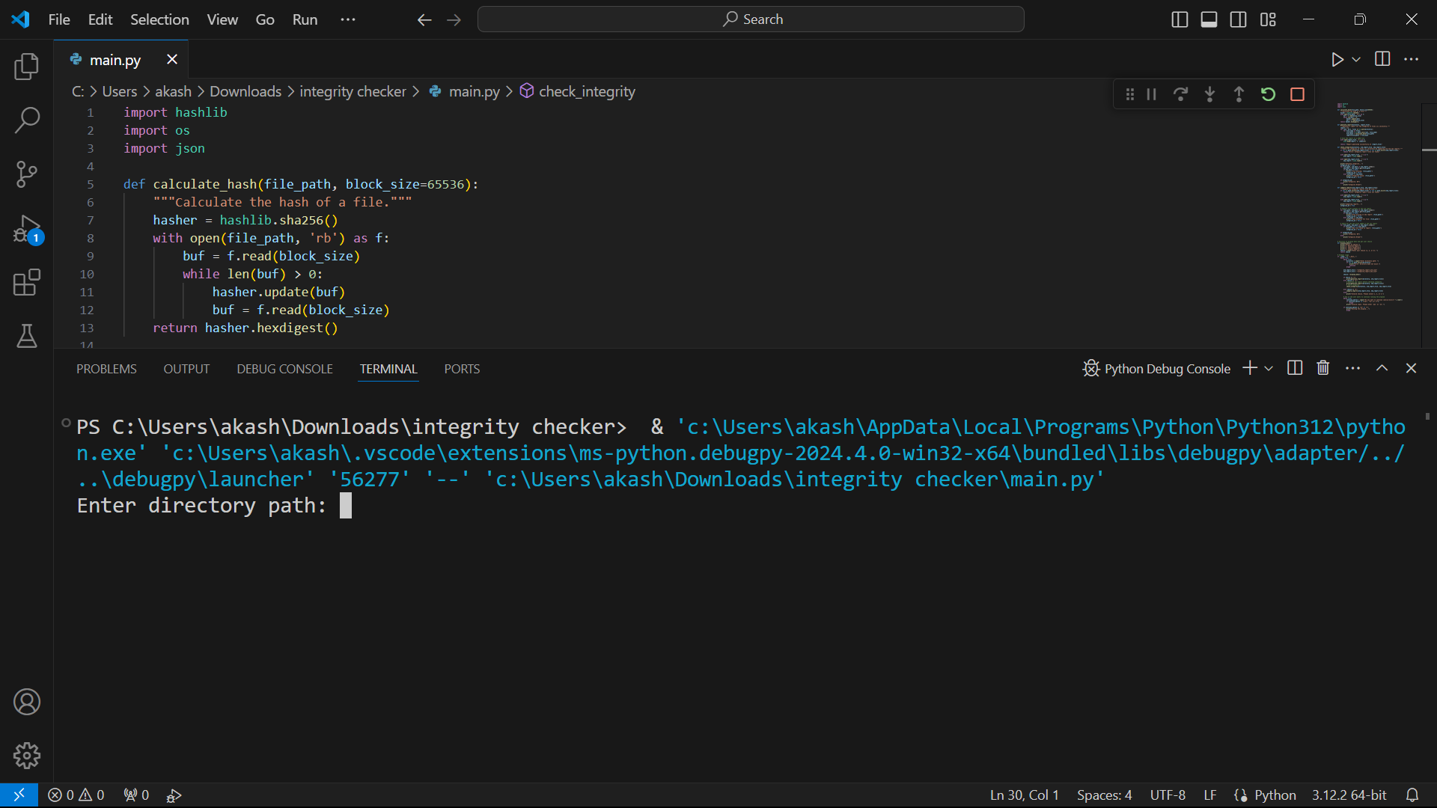

* Now choose option (1) to Generate a report of the directory

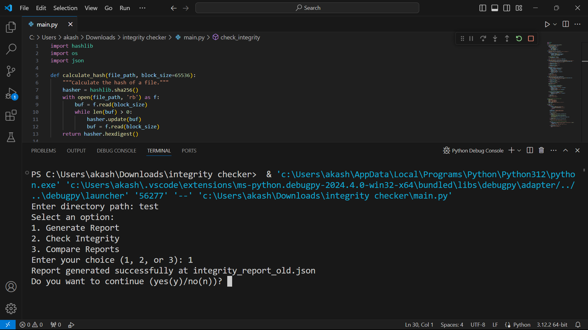

* The report of test Folder is this , It create hashes of the file.(integrate _report_old.)

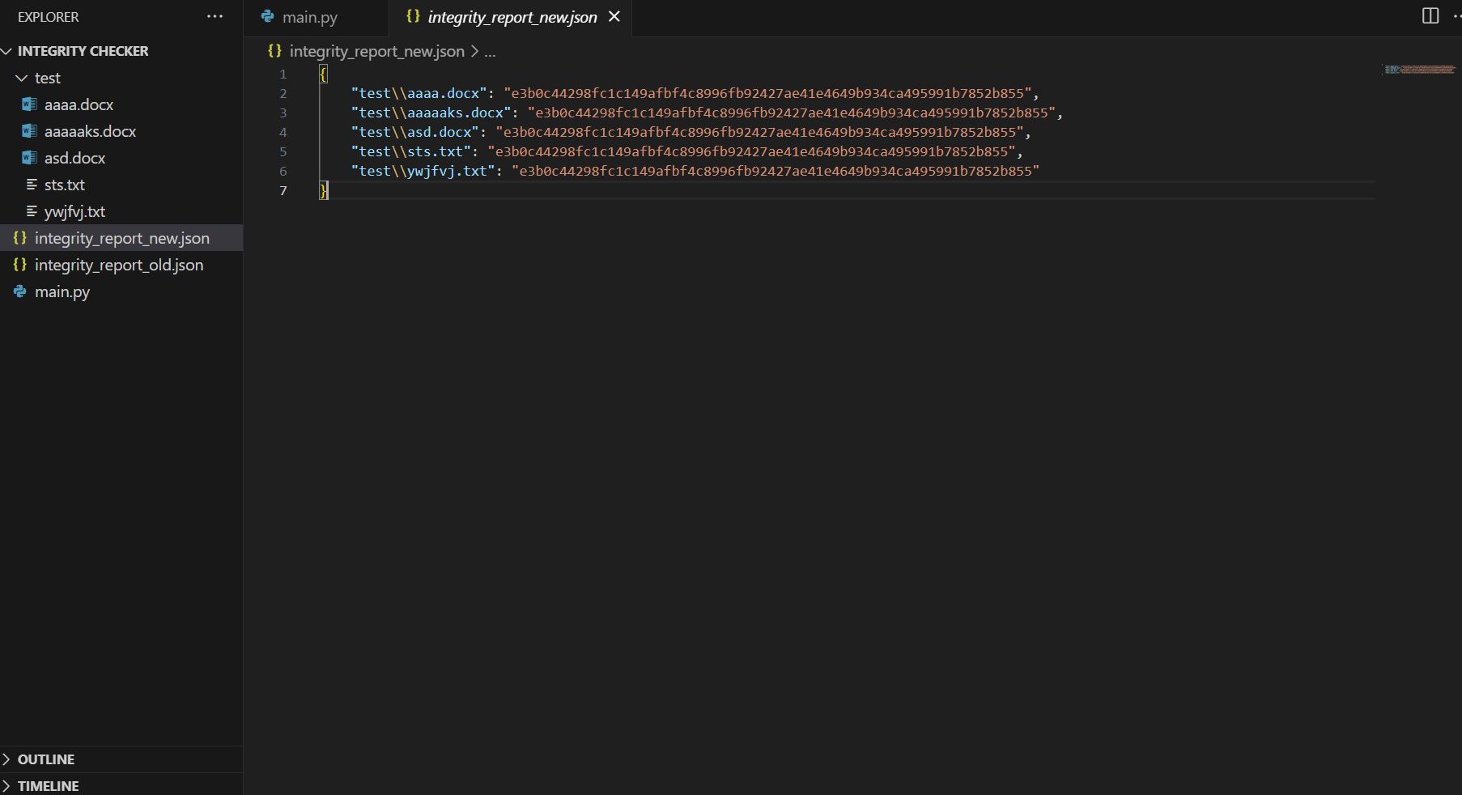

* Now option 2

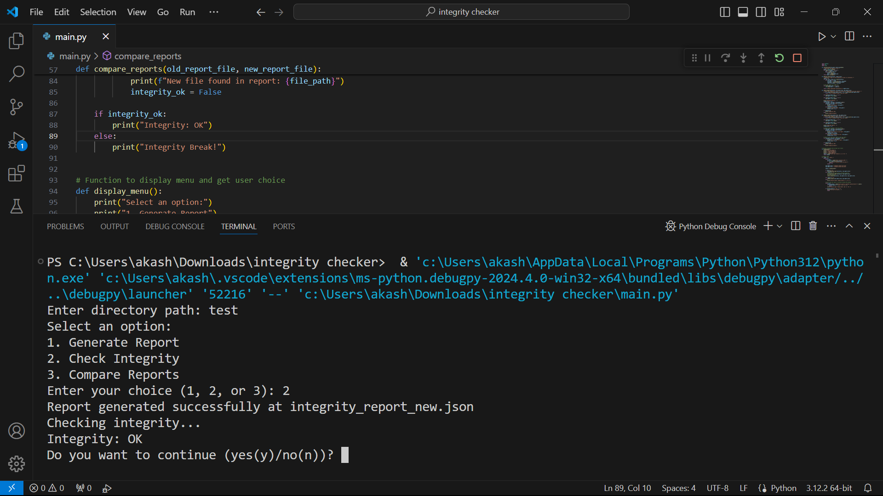

* Now option 3

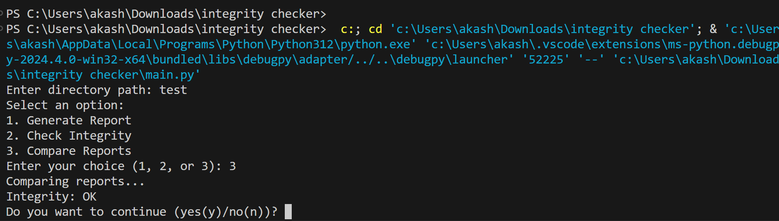

* 1. **Conclusion**

The Integrity Checker, often unsung amidst the cacophony of cybersecurity tools, emerges as a stalwart protector in the digital domain. While it may lack the flashy allure of firewalls or the immediate threat response of anti-virus software, its role in safeguarding the bedrock of system functionality—core files—is nothing short of indispensable. It operates in the shadows, quietly monitoring, and scrutinizing every byte, ensuring that the very essence of your system remains intact and impervious to malicious intent.

In essence, the Integrity Checker orchestrates a symphony of defense, employing multiple layers of security to fortify the fortress of your digital assets. Like a vigilant sentinel, it stands guard, ever-watchful for the subtlest tremors that could signify an impending breach. Its proactive posture allows it to detect and intercept potential threats—be it the insidious infiltration of malware or the audacious attempt at privilege escalation—before they can inflict irreparable harm upon your system.

But the Integrity Checker's role extends beyond mere threat detection; it serves as a beacon of foresight, illuminating the path to system stability and operational continuity. Through its meticulous monitoring and early warning mechanisms, it identifies and addresses potential issues with surgical precision, preempting system crashes and mitigating disruptions to workflow. Its ability to trigger immediate alerts in the face of discrepancies ensures swift response and containment of security incidents, while its detailed logs serve as a trail of breadcrumbs for post-incident analysis and forensic investigation.

Yet, the impact of the Integrity Checker reverberates far beyond the confines of individual systems, casting a protective mantle over entire organizations. By minimizing downtime resulting from security breaches, it not only safeguards financial assets but also preserves invaluable reputational capital. Moreover, by upholding the sanctity of file integrity, it erects a formidable barrier against unauthorized access attempts, fortifying the digital ramparts of data security.

However, the Integrity Checker's journey is not one of stagnation but of perpetual evolution, a testament to its adaptability in the face of ever-evolving cyber threats. As adversaries employ increasingly sophisticated tactics, the Checker must rise to the challenge, leveraging advancements in machine learning, real-time monitoring, and cloud-based solutions to bolster its defensive arsenal. Automation and self-healing functionalities will streamline the remediation process, while user-centric features and awareness training will empower individuals to become active participants in the ongoing battle for system security.

In summation, the Integrity Checker transcends its status as a mere tool, embodying the ethos of proactive defense essential in today's digital landscape. By diligently verifying file integrity, it empowers users to erect an impregnable bulwark against cyber threats, ensuring the stability, reliability, and security of the digital realm. As technology marches inexorably forward, this silent guardian will continue to adapt, innovate, and evolve, steadfast in its mission to safeguard the integrity of our digital world for generations to come.

* 1. **Significance and Impact**

The significance and impact of the Integrity Checker within the realm of cybersecurity cannot be overstated. It serves as a linchpin in the defense strategy of any organization, ensuring the integrity, authenticity, and reliability of critical system files. Let's delve into the profound significance and far-reaching impact of the Integrity Checker:

1. **Fortification of Cyber Defenses:**

* Guardian of Core Files: The Integrity Checker stands as a vigilant guardian, tirelessly monitoring critical system files for any signs of tampering or unauthorized modification.
* Early Threat Detection: By actively detecting and flagging potential threats such as malware injections or unauthorized access attempts, it enables organizations to adopt a proactive stance against cyber attacks.

1. **Preservation of System Stability:**

* Prevention of System Crashes: By identifying discrepancies and potential issues early on, the Integrity Checker helps prevent system crashes, freezes, and unexpected downtime, thereby ensuring operational continuity.
* Minimization of Disruptions: Its ability to trigger real-time alerts allows for swift intervention, minimizing disruptions to workflows and productivity.

1. **Cost Savings and Risk Mitigation**:

* Reduction in Downtime: By minimizing downtime resulting from security breaches, the Integrity Checker translates into significant cost savings for organizations, preserving financial resources and operational efficiency.
* Mitigation of Reputation Risks: Timely detection and containment of security incidents safeguard an organization's reputation, instilling trust among customers, partners, and stakeholders.

1. **Strengthening of Data Security:**

* Barrier Against Unauthorized Access: Upholding the integrity of system files acts as a potent barrier against unauthorized access attempts, thwarting potential data breaches and safeguarding sensitive information
* Reinforcement of Compliance Requirements: Compliance frameworks often mandate regular integrity checks as part of data security measures, ensuring adherence to regulatory standards and industry best practices.

1. **Cultivation of Security Awareness:**

* Fostering a Culture of Vigilance: By promoting regular integrity checks and proactive security measures, the Integrity Checker fosters a culture of security awareness within organizations, making individuals more vigilant and proactive in safeguarding their systems.
* Empowerment Through Education: Awareness training and user-centric features empower individuals to recognize and respond to potential security threats, transforming them into active participants in the defense against cyber attacks.

1. **Adaptability and Continuous Evolution:**

* Adaptation to Emerging Threats: As cyber threats evolve, so too does the Integrity Checker. It embraces advancements in technology, such as machine learning-based threat detection and real-time monitoring, to stay ahead of emerging threats and vulnerabilities.
* Innovation for Future Readiness: Continuous innovation and refinement ensure that the Integrity Checker remains at the forefront of cybersecurity, ready to confront the challenges of tomorrow's digital landscape.

In essence, the Integrity Checker serves as a cornerstone of cybersecurity, safeguarding the integrity and security of organizational systems with unwavering diligence. Its impact resonates across every facet of an organization, from bolstering defenses against cyber threats to fostering a culture of security consciousness. As technology advances and threats evolve, the Integrity Checker remains a steadfast ally, adapting and innovating to ensure the resilience and integrity of our digital infrastructure.

* 1. **Future Scope**

The future scope of integrity checks encompasses a wide array of possibilities, driven by the continuous evolution of technology and the ever-changing landscape of cybersecurity threats. Here are several avenues for future development and enhancement in the realm of integrity checks:

**1. Advancements in Threat Detection:**

Machine Learning Algorithms: Integration of machine learning algorithms for more sophisticated threat detection, enabling the Integrity Checker to identify patterns and anomalies indicative of potential security breaches.

Behavioral Analysis: Implementation of behavioral analysis techniques to detect deviations from normal system behavior, allowing for proactive identification of emerging threats.

**2. Real-Time Monitoring and Response:**

Continuous Monitoring: Transition towards real-time monitoring capabilities, enabling the Integrity Checker to detect and respond to security incidents as they occur, thereby reducing response times and minimizing the impact of breaches.

Automated Remediation: Integration of automated remediation mechanisms to swiftly address security incidents, such as isolating compromised systems or rolling back unauthorized changes.

**3. Cloud-Based Solutions:**

Cloud Integration: Development of cloud-based integrity check solutions, allowing organizations to monitor and secure distributed systems and cloud environments with ease.

Scalability and Flexibility: Scalable architecture to accommodate the dynamic nature of cloud-based infrastructures, providing flexibility and adaptability to evolving organizational needs.

**4. Enhanced User-Centric Features:**

Intuitive Interfaces: Designing user-friendly interfaces and dashboards to provide clear insights into system integrity status, facilitating ease of use and interpretation for administrators and end-users.

Interactive Reporting: Implementation of interactive reporting tools to enable users to drill down into integrity check results, investigate incidents, and take appropriate remedial actions.

**5. Integration with Security Ecosystem:**

Cross-Platform Integration: Seamless integration with existing security solutions and frameworks, including SIEM (Security Information and Event Management) systems, IDS/IPS (Intrusion Detection/Prevention Systems), and EDR (Endpoint Detection and Response) platforms.

Collaborative Defense: Collaboration with threat intelligence platforms to leverage threat intelligence feeds and enhance the Integrity Checker's ability to detect and respond to emerging threats.

**6. Automation and Self-Healing:**

Automated Workflows: Streamlining integrity check workflows through automation, including scheduled scans, baseline generation, and incident response processes.

Self-Healing Mechanisms: Implementation of self-healing mechanisms to automatically restore files to their original state in the event of unauthorized modifications, minimizing manual intervention and reducing downtime.

**7. Compliance and Regulatory Compliance:**

Enhanced Compliance Features: Incorporation of features tailored to regulatory compliance requirements, ensuring adherence to industry standards such as GDPR, HIPAA, PCI DSS, and others.

Audit Trail and Documentation: Robust audit trail capabilities to maintain detailed records of integrity checks and compliance activities, facilitating regulatory audits and compliance reporting.

**8. Continuous Innovation and Research:**

Research and Development: Continued investment in research and development to explore emerging technologies, methodologies, and best practices in the field of integrity checks.

Collaborative Initiatives: Collaboration with academic institutions, industry partners, and cybersecurity communities to foster innovation and knowledge sharing in the domain of system integrity and security.

In summary, the future scope of integrity checks is expansive and dynamic, driven by advancements in technology, evolving threat landscapes, and the increasing complexity of organizational IT infrastructures. By embracing emerging technologies, enhancing user-centric features, and fostering collaboration within the cybersecurity community, integrity checks will continue to play a pivotal role in safeguarding the integrity, security, and resilience of digital systems in the years to come.

1. **References**

* Confidentiality, integrity, availability: The three components of the CIA triad.
* Available at: Confidentiality, Integrity, Availability: The three components of the CIA Triad « Stack Exchange Security Blog (blogoverflow.com)
* Web testing: A complete guide about testing web applications (2007) Available at:
* http://www.softwaretestinghelp.com/web-application-testing
* timothyyong.pdf (ncirl.ie)
* 10 Common Website Vulnerabilities: Security Tips | Toptal®